
ECA13 – MICROWAVE ENGINEERING
CO1 APPLICATION-BASED ASSESSMENT
ANALYSIS, DESIGN AND VERIFICATION OF A MICROWAVE TRANSMISSION LINE AND NETWORK FOR A 24 GHz AUTOMOTIVE BLIND-SPOT RADAR FRONT-END
Submitted by: Mollala Krishna Sri Reddy
Register Number: [192512116]
Department: Electronics and Communication Engineering
Course: ECA13 – Microwave Engineering
Academic Year: 2027–2028
Submitted to: DR.S.KAMATCHI

ABSTRACT
This assignment presents the analysis and preliminary design of a printed transmission path for a 24 GHz automotive blind-spot radar front-end operating in the 24.05–24.25 GHz band. Four transmission structures – coaxial line, rectangular waveguide (WR-42), stripline and microstrip – are compared for propagation mode, loss, size, shielding, cost and integration. A 50 Ω microstrip line is selected and designed on two laminates: Rogers RO4350B (initial design) and RO3003 with low-profile copper (improved design). Quasi-static microstrip equations with Getsinger dispersion are used to obtain the line width, effective permittivity, guided wavelength and velocities; a loss budget is built from skin depth, surface roughness, loss tangent, radiation and transition allowances. The line must feed a 100 Ω patch-array element, so a quarter-wave transformer is designed, the line is represented by ABCD matrices, and S-parameters are derived and checked for reciprocity and losslessness. The analytical model was executed in Python (NumPy) and cross-checked with an independent scikit-rf microstrip model; the results are analytical estimates for an undergraduate design study and are not measured results or output from a full-wave electromagnetic solver.
CONTENTS
- Design basis and assumptions
- Stage 1 – Application and quantified requirements
- Stage 2 – Transmission-structure evaluation and selection
- Stage 3 – Mode and propagation model and dimensions
- Stage 4 – Loss budget and loss-reduction design
- Stage 5 – Network model, matching and S-parameters
- Stage 6 – Validation, critique and tolerance analysis
- Final engineering decision
- References
- Appendix A – Formula summary
- Appendix B – Code listing
DESIGN BASIS AND ASSUMPTIONS
The operating band is 24.05–24.25 GHz (centre frequency f₀ = 24.15 GHz), the ISM band used by narrowband 24 GHz automotive radar. The initial board uses Rogers RO4350B (design εr = 3.66, tan δ = 0.0037, h = 0.254 mm) with 17.5 µm (½ oz) electro-deposited copper of RMS roughness 1.0 µm. The improved board uses Rogers RO3003 (εr = 3.00, tan δ = 0.0010, h = 0.254 mm) with low-profile copper of RMS roughness 0.3 µm. Copper conductivity is 5.8 × 10⁷ S/m and the system impedance is 50 Ω. Laminate values are datasheet-type values and must be re-checked against the supplier revision actually ordered.
Important limitation: the conductor, dielectric and mismatch terms in this report are calculated from closed-form models. The radiation term (0.5 open-end equivalents over the route) and the transition term (0.10 dB per wire-bonded transition initially, 0.06 dB per flip-chip transition after redesign) are engineering allowances, not calculated or measured values. Nothing here is a measured result or a full-wave simulation; those remain to be done (Stage 6).

STAGE 1 – FORMULATE THE APPLICATION AND OPERATING REQUIREMENT

Application and importance
The selected application is the printed RF feed line between the transceiver MMIC of a 24 GHz blind-spot-detection radar and its series-fed microstrip patch-antenna array (civil / automotive category). The radar transmits a frequency-modulated carrier and measures range and relative speed of vehicles in the adjacent lane. Attenuation in the feed lowers the transmitted power and the receiver sensitivity, which reduces detection range; reflections at the antenna element distort the swept-frequency (FMCW) signal and raise range sidelobes. A controlled impedance, low loss and a compact layout are therefore essential, and the line must be cheap enough for mass production.
Microwave engineering grew from Maxwell’s field theory (1860s) and Hertz’s experimental demonstration of electromagnetic waves (late 1880s). The cavity magnetron (1940) and wartime radar drove practical waveguide components. Communication satellites in the 1960s extended microwave links, and solid-state devices and monolithic microwave integrated circuits (MMICs) from the 1970s–80s allowed whole front-ends to be printed on one board. Automotive radar followed, first at 24 GHz and then at 77 GHz, and today’s 5G and developing 6G systems continue the move from bulky waveguide assemblies to compact integrated structures.

Frequency-band comparison
Band | Example frequency | Free-space wavelength | Advantages | Limitations for this application
X | 10 GHz | 29.98 mm | Lowest line loss; relaxed tolerances | Large antenna array; narrow allocated bandwidth for short-range radar; poorer angular resolution for a given size
K (selected) | 24.15 GHz | 12.41 mm | Compact array; ISM allocation 24.05–24.25 GHz; mature low-cost MMICs | Moderate line loss; rain and vapour attenuation noticeable only for long paths
Ka | 35 GHz | 8.57 mm | Smaller array; wider bandwidth | Higher conductor/dielectric loss; tighter etch tolerance; higher cost; fewer automotive MMIC options

Wavelength is λ₀ = c/f. At 24.15 GHz, λ₀ = (3.00 × 10⁸)/(24.15 × 10⁹) = 12.414 mm. Atmospheric absorption near 24 GHz is of the order of 0.1–0.2 dB/km (water-vapour line near 22 GHz) and heavy rain adds a few dB/km (the exact values should be taken from ITU-R P.838). The radar range is below about 100 m, so the total effect is a fraction of a dB and does not drive the choice. The K band is selected because it gives a compact antenna and a usable allocated band while keeping the line loss acceptable; 77 GHz is outside the L–Ka bands compared here and would raise loss and cost further.

Quantified requirement specification
Parameter | Target / design assumption | Reason
Application category | Civil – automotive blind-spot radar front-end | Short-range radar feed line
Centre frequency | 24.15 GHz | Centre of the 24.05–24.25 GHz ISM band
Design bandwidth | 24.05–24.25 GHz (0.2 GHz, 0.83 %) | Narrowband FMCW sweep
Reference impedance | 50 Ω (load: 100 Ω patch-array element) | Common RF impedance; patch edge resistance assumed 100 Ω
Line length | 30 mm | MMIC-to-antenna board interconnect
Insertion loss | ≤ 1.0 dB over 30 mm, excluding active devices | Preserves transmit power and receiver noise figure
Return loss / VSWR | ≥ 15 dB (VSWR ≤ 1.43) across the band | Limits reflected power and FMCW ripple
Isolation / shielding | ≥ 30 dB between adjacent TX and RX paths | Board-level EMC target; to be measured
Power level | +10 dBm (10 mW) conducted; margin to +20 dBm | Typical short-range radar transmitter
Size | Line ≤ 30 mm; 0.254 mm substrate | Compact module
Cost | Low-cost 2-layer PCB; budget to be confirmed from a fabrication quote | Cost depends on laminate and quantity

Constraints and acceptance criteria
- EMI/EMC: continuous ground plane, short return-current paths, via fence along the line at a pitch of at most λg/10 ≈ 0.73 mm, and no long unshielded transitions.
- Safety: with the assumed +10 dBm conducted power and an assumed 15 dBi antenna gain, the EIRP is about +25 dBm (0.316 W). At 0.2 m the power density is S = EIRP/(4πr²) = 0.316/(4π × 0.2²) ≈ 0.63 W/m², about 16 times below the commonly quoted 10 W/m² general-public reference level (ICNIRP). This is only a design-stage check; a real product needs formal assessment of duty cycle and distance.
- Environment: automotive temperature range and humidity change εr and loss; RO4350B has a positive and RO3003 a very small thermal coefficient of εr (datasheet values to be confirmed). Copper roughness changes conductor loss.
- Acceptance: the line must meet the loss, return-loss, isolation and size targets in the table, with the worst-case tolerance corner still passing. All targets remain preliminary until simulated and measured.
Stage 1 deliverable: Application → Category → Frequency band → Transmission requirements → Constraints → Acceptance criteria, as tabulated above.

STAGE 2 – EVALUATE AND SELECT THE TRANSMISSION STRUCTURE

Propagation modes
Structure | Mode / field behaviour at 24.15 GHz | Strengths | Limitations
Coaxial line (2.92 mm, air) | TEM, no cutoff; first higher mode TE11 at 45.5 GHz; Z₀ = 50.0 Ω | Fully shielded, flexible, well-defined 50 Ω ports | Connector size and cost; not printable; awkward to attach to MMIC and patch array
Rectangular waveguide (WR-42, 10.668 × 4.318 mm) | TE10 dominant, fc = 14.05 GHz; TE20 at 28.10 GHz; no TEM | Lowest loss and highest power | Bulky; needs waveguide-to-microstrip transitions; expensive
Stripline (b = 0.508 mm) | TEM in a homogeneous dielectric between two ground planes | Good shielding, no radiation | Buried: vias needed to reach top-layer MMIC and patch; two laminates
Microstrip (h = 0.254 mm) | Quasi-TEM: fields in both substrate and air | Compact, low-cost, patch antenna and MMIC on the same layer | Radiation, dispersion, open structure

A hollow single-conductor waveguide cannot support TEM because a TEM wave needs both E and H transverse to the direction of propagation, and for a TEM wave the transverse field must satisfy Laplace’s equation with a potential difference between two conductors; inside a single hollow conductor the transverse potential is constant, so the field is zero. Hollow guides therefore support only TE and TM modes, each with a non-zero cutoff frequency. Microstrip is not pure TEM because the field lies partly in the dielectric (εr) and partly in air (ε₀); the two media give different phase velocities for the same field pattern, so a pure TEM wave cannot satisfy the boundary conditions at the dielectric–air interface. Small longitudinal field components appear and εeff varies with frequency, which is called quasi-TEM behaviour.

Weighted decision matrix
Criterion | Weight (%) | Coax /5 | Waveguide /5 | Stripline /5 | Microstrip /5
Frequency / bandwidth suitability | 10 | 4 | 5 | 4 | 4
Low loss | 20 | 4 | 5 | 3 | 3
Power handling | 5 | 4 | 5 | 3 | 3
Size and weight | 15 | 3 | 1 | 3 | 5
Cost | 15 | 2 | 1 | 3 | 5
EMI shielding | 15 | 5 | 5 | 5 | 3
Integration with MMIC / antenna | 20 | 2 | 1 | 3 | 5
Weighted score /5 | 100 | 3.30 | 3.00 | 3.40 | 4.10

Selected structure: microstrip (score 4.10/5), ahead of stripline (3.40), coax (3.30) and waveguide (3.00). Scores are engineering judgements on a 1–5 scale; loss, size and shielding scores are supported by the numbers in the next table.
Structure at 24.15 GHz | Conductor (dB/m) | Dielectric (dB/m) | Total (dB/m) | Loss over 30 mm (dB) | Wavelength (mm)
Coax (air) | 1.27 | 0 | 1.27 | 0.038 | 12.41
WR-42 (air) | 0.34 | 0 | 0.34 | 0.010 | λg = 15.26
Stripline | 25.32 | 15.56 | 40.88 | 1.23 | 6.49
Microstrip | 25.38 | 12.30 | 37.68 | 1.13 | 7.25

Conductor loss for coax, waveguide and stripline uses the standard closed-form expressions with the same copper surface resistance Rs = 0.0405 Ω/□; stripline and microstrip include the same roughness factor of 1.92. Waveguide and coax are drawn smooth.

Sensitivity and strongest alternative
To test the ranking, the weights were blended linearly from the base case towards a performance-priority set (frequency 20, loss 40, power 15, shielding 25, others 0). The ranking reverses when waveguide overtakes microstrip at a blend of 0.38, where size, cost and integration have together dropped from 50 % to 31 % of the total weight. Coax overtakes at a blend of 0.43 and stripline last, at 0.58 (size, cost and integration then total 21 %). Under the pure performance-priority weights the scores are waveguide 5.00, coax 4.25, stripline 3.70, microstrip 3.20, so the choice is robust only while integration, size and cost carry about a third of the weight or more.
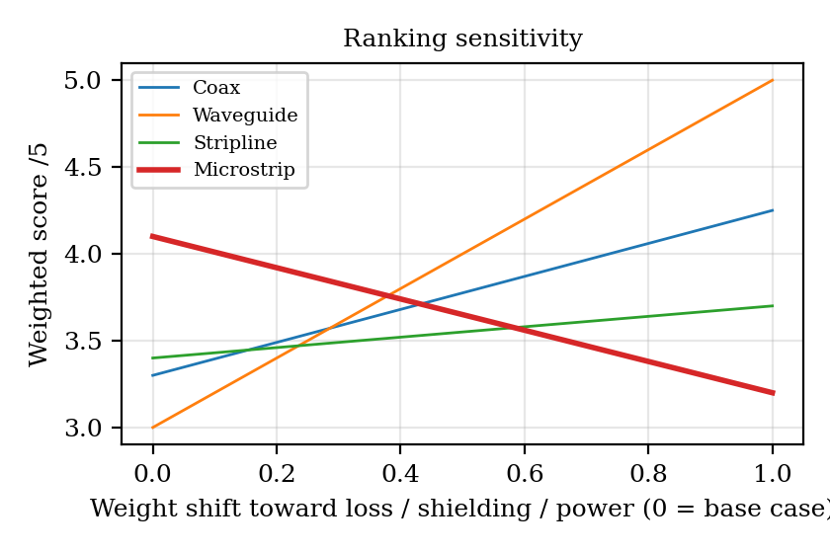
Figure 1 – Weighted score versus weight shift towards performance criteria
Frequency sensitivity. Microstrip loss with the initial geometry rises from 23.4 dB/m at 12.075 GHz to 37.7 dB/m at 24.15 GHz and 61.3 dB/m at 48.3 GHz (1.84 dB over 30 mm), and h/λd grows from 0.020 to 0.078, so dispersion, launch parasitics and tolerance get worse. For the structure not selected, WR-42 cannot be used at half the frequency: 12.075 GHz is below its 14.05 GHz cutoff, the field is evanescent with α = 151 Np/m, i.e. 39 dB over only 30 mm, and a larger guide (about WR-75) would be needed. At double the frequency WR-42 supports 8 modes (TE10, TE20, TE01, TE11, TM11, TE30, TE21, TM21) so a smaller guide (about WR-19) would be needed to keep single-mode operation. Waveguide becomes attractive when path length, power or loss dominates.
Defence against the strongest alternative (stripline). Stripline has similar loss (40.9 dB/m against 37.7 dB/m) and better shielding, but both the transceiver MMIC and the patch array sit on the top layer, so every end of a stripline would need a via transition, which adds discontinuities and radiation at 24 GHz, and the stack needs two laminate layers. Microstrip puts the line, the matching section and the antenna on one layer at lower cost. Over 30 mm the waveguide loss is only 0.010 dB, but two waveguide-to-board transitions would each add loss of the order of a few tenths of a dB (typical values, to be confirmed), cancelling the advantage.
Design Decision 1: For the 24 GHz blind-spot radar feed I select 50 Ω microstrip over stripline (and over WR-42 waveguide and 2.92 mm coax) because it integrates directly with the MMIC and patch array, is smallest and cheapest, and meets the loss budget with margin after the Stage 4 redesign; stripline or waveguide would be chosen instead if shielding or loss dominated the weights.

STAGE 3 – DEVELOP THE MODE AND PROPAGATION MODEL

Transmission-line equations
For a uniform line with per-unit-length R, L, G and C, the telegrapher’s equations are:
∂V/∂z = −(R + jωL) I ∂I/∂z = −(G + jωC) V
γ = α + jβ = √[(R + jωL)(G + jωC)] Z₀ = √[(R + jωL)/(G + jωC)]
For a low-loss line (R ≪ ωL, G ≪ ωC): α ≈ (R/2)√(C/L) + (G/2)√(L/C) = R/(2Z₀) + GZ₀/2, β ≈ ω√(LC), vp ≈ 1/√(LC) and Z₀ ≈ √(L/C). The reflection coefficient of a load is Γ = (ZL − Z₀)/(ZL + Z₀).

Field derivation and assumptions
Maxwell’s curl equations in a source-free region give the wave equation (∇² + k²)E = 0 with k² = ω²με. For a wave travelling as e^(−γz), the fields split into transverse and longitudinal parts. For TEM (Ez = Hz = 0) the transverse fields satisfy ∇t²Φ = 0, so the field is the electrostatic field of the cross-section, γ = jk, and V and I are unique with Z₀ = √(L/C). For a hollow guide with Hz ≠ 0 (TE modes) the solution is Hz = H₀ cos(mπx/a) cos(nπy/b) e^(−jβz) with β = √(k² − kc²), kc = π√((m/a)² + (n/b)²), and fc = (c/2)√((m/a)² + (n/b)²).
For microstrip the quasi-static assumption is used: the field is taken as the static field of the cross-section, so the capacitance per unit length C with the dielectric and C_air with the dielectric removed give εeff = C/C_air, vp = c/√εeff and Z₀ = 1/(c√(C·C_air)). This holds when h ≪ λ (here h/λd = 0.039); at 24 GHz dispersion is added with the Getsinger model, εeff(f) = εr − (εr − εeff₀)/(1 + G(f/fp)²), where fp = Z₀/(2μ₀h) and G = 0.6 + 0.009Z₀. Assumptions: perfect-conductor field shape, homogeneous isotropic dielectric, uniform cross-section, and negligible radiation from the straight line.

TEM, TE, TM and quasi-TEM comparison
Mode | Field components | Cutoff and dispersion | Wave impedance and use here
TEM | Ez = 0, Hz = 0 | No cutoff; non-dispersive in a homogeneous medium | ZTEM = η = √(μ/ε); coax and stripline reference
TE | Ez = 0, Hz ≠ 0 | Cutoff fc; dispersive | ZTE = η/√(1 − (fc/f)²) = 463.5 Ω for WR-42 TE10 at 24.15 GHz
TM | Hz = 0, Ez ≠ 0 | Cutoff fc; dispersive | ZTM = η√(1 − (fc/f)²); higher waveguide modes
Quasi-TEM | Mostly transverse; small Ez, Hz | No cutoff; εeff rises slowly with f | Z₀ ≈ 50 Ω; the intended mode of this design

TEM (quasi-TEM) is the best mode for this application because it has no cutoff, a wide single-mode range, nearly constant impedance and a unique voltage and current. TE10 in WR-42 would give lower loss, but only over the 17.6–26.7 GHz recommended range (1.25 fc to 0.95 f20), with strong dispersion (vg = 2.438 × 10⁸ m/s, vp = 3.686 × 10⁸ m/s).

Dimension design
Substrate height is fixed at h = 0.254 mm, which keeps h/λd = 0.039 well under 0.1 so that surface-wave coupling and radiation are small. The strip width is found by solving the Hammerstad–Jensen Z₀(W/h) equation with the thickness correction ΔW = (t/π)[1 + ln(2h/t)] for Z₀ = 50 Ω; the transformer width is found for Zt = √(50 × 100) = 70.71 Ω.
Parameter at 24.15 GHz | Initial (RO4350B) | Improved (RO3003) | Comment
Relative permittivity εr / tan δ | 3.66 / 0.0037 | 3.00 / 0.0010 | Datasheet-type values
Substrate h / copper t | 0.254 mm / 17.5 µm | 0.254 mm / 17.5 µm | Selected
50 Ω strip width W | 0.532 mm | 0.615 mm | Starting values; solver refinement needed
Transformer width Wt (70.71 Ω) | 0.277 mm | 0.331 mm | Zt = 70.71 Ω
Static εeff₀ | 2.858 | 2.425 | Hammerstad–Jensen
εeff at 24.15 GHz (dispersive) | 2.931 | 2.477 | Getsinger
Z₀ at 24.15 GHz (dispersive) | 49.4 Ω | 49.5 Ω | Drops slightly with f
Phase velocity vp | 1.751 × 10⁸ m/s | 1.905 × 10⁸ m/s | c/√εeff
Group velocity vg | 1.712 × 10⁸ m/s | 1.869 × 10⁸ m/s | From dβ/dω, numerical
Guided wavelength λg | 7.251 mm | 7.887 mm | vp/f
Phase constant β | 866.5 rad/m | 796.6 rad/m | 2π/λg
Group delay over 30 mm | 0.175 ns | 0.161 ns | L/vg
Quarter-wave length λg,t/4 | 1.861 mm | 2.018 mm | At f₀
Wave impedance | Z₀ = 50 Ω (unique V, I) | Z₀ = 50 Ω | Quasi-TEM
Dispersion knee fp = Z₀/(2μ₀h) | 78.3 GHz | 78.3 GHz | 3.2 × f₀
Lateral higher-order mode | 123.6 GHz | 120.8 GHz | c/[√εr (2W + 0.8h)] (approx.)
Surface-wave TE1 cutoff | 180.9 GHz | 208.6 GHz | c/(4h√(εr − 1))
Single-mode range | DC – 78 GHz (practical) | DC – 78 GHz (practical) | Operating band is 24.05–24.25 GHz

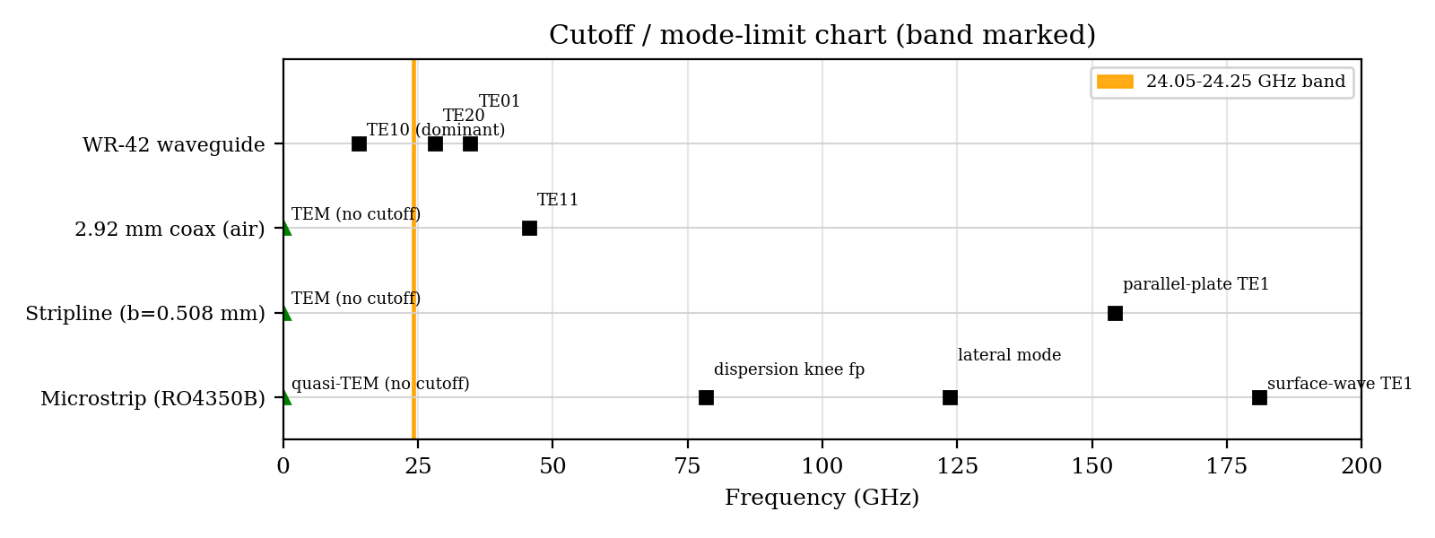
Figure 2 – Cutoff and mode-limit chart for the four structures (operating band shaded)

Worked calculation (initial design, with units)
Effective width: ΔW = (t/π)[1 + ln(2h/t)] = (17.5 µm/π)[1 + ln(2 × 254/17.5)] = 24.3 µm, so We = 0.5324 + 0.0243 = 0.5567 mm and u = We/h = 2.192.
Z₀₁ = 60 ln[F/u + √(1 + (2/u)²)] with F = 6 + (2π − 6)exp[−(30.666/u)^0.7528] = 6.000, giving Z₀₁ = 84.53 Ω in air. The Hammerstad–Jensen εeff = (εr + 1)/2 + (εr − 1)/2 (1 + 10/u)^(−ab) with a = 0.9997 and b = 0.5383 gives εeff₀ = 2.858. Then Z₀ = Z₀₁/√εeff₀ = 84.53/1.6906 = 50.00 Ω ✓.
At f₀ the dispersive εeff = 2.931, so vp = c/√εeff = 2.998 × 10⁸/1.7120 = 1.751 × 10⁸ m/s, λg = vp/f = 1.751 × 10⁸/(24.15 × 10⁹) = 7.251 mm, β = 2π/λg = 866.5 rad/m, and group delay = 0.030/vg = 0.175 ns.

Higher-order modes
The lowest unwanted mode limits are the dispersion knee (78 GHz, 3.2 times f₀), the lateral resonance across the strip and ground (124 GHz, 5.1 times f₀) and the TE1 surface wave (181 GHz). The TM0 surface wave has no cutoff but is weakly excited when h/λd is small. The main practical risks are: (i) the feed or MMIC transition launching parallel-plate or surface waves; (ii) a metal cover or enclosure forming a cavity or waveguide mode; and (iii) via-fence modes between ground vias. Proposed changes: keep h = 0.254 mm; place ground vias at a pitch of at most λg/10 ≈ 0.73 mm; keep a cover at least about 10 h above the line and add absorber if used; and use a grounded coplanar launch with symmetric via placement to avoid exciting odd modes. Mode degeneracy does not occur for the quasi-TEM mode, but TE/TM pairs such as TE11/TM11 in WR-42 are degenerate (both at 37.45 GHz), another reason to avoid waveguide at higher frequency.
Design Decision 2: The dominant mode is quasi-TEM with no cutoff; the first limits are the dispersion knee at 78 GHz and the lateral mode at 124 GHz; the single-mode range is DC to about 78 GHz (practical), which contains the 24.05–24.25 GHz band with a margin of 3.2×; therefore the chosen dimensions (W = 0.532 mm, h = 0.254 mm on RO4350B) are acceptable as a starting design, subject to full-wave confirmation of the launch.

STAGE 4 – EVALUATE LOSSES AND DESIGN A LOSS-REDUCTION STRATEGY

Skin depth and surface resistance
For copper (σ = 5.8 × 10⁷ S/m, µr = 1) at 24.15 GHz: δ = √[2/(ωµσ)] = 0.425 µm and Rs = √(πfµ/σ) = 0.0405 Ω/□. Since the 17.5 µm copper is about 41 skin depths thick, current flows in a thin surface layer, and roughness of 1.0 µm RMS (larger than δ) increases conductor loss by the Hammerstad factor K = 1 + (2/π) arctan[1.4(Δ/δ)²] = 1.92; for 0.3 µm RMS low-profile copper K = 1.39.

Worked conductor and dielectric attenuation (initial design)
Conductor: αc = Rs K/(Z₀W) = (0.0405 × 1.918)/(50 × 0.532 × 10⁻³) = 2.922 Np/m = 2.922 × 8.686 = 25.38 dB/m.
Dielectric: αd = k₀ εr (εeff − 1) tan δ/[2√εeff (εr − 1)], with k₀ = 2πf/c = 506.1 rad/m: αd = (506.1 × 3.66 × 1.858 × 0.0037)/(2 × 1.691 × 2.66) = 1.416 Np/m = 12.30 dB/m. This includes the filling factor (εeff − 1)/(εr − 1), which reduces the loss below the plane-wave value in a homogeneous dielectric.

Loss budget
Radiation: the Hammerstad open-end radiation fraction is 0.86 % at h/λ₀ = 0.0205; with 0.5 open-end equivalents allocated to the launch and bends, the radiation loss is 0.019 dB. Transition loss is allocated as 2 × 0.10 dB (wire-bond transitions). Mismatch loss at the 100 Ω load of the initial design is −10 log(1 − |Γ|²) = −10 log(1 − 0.1111) = 0.512 dB. Both allocations are engineering assumptions.
Loss component | Initial (dB/m) | Improved (dB/m) | Initial (dB, 30 mm) | Improved (dB, 30 mm) | % of total (initial → improved) | Trade-off / remarks
Conductor loss | 25.38 | 15.89 | 0.761 | 0.477 | 40.9 → 67.2 | Low-profile copper (K 1.92 → 1.39); wider line on RO3003
Dielectric loss | 12.30 | 3.02 | 0.369 | 0.091 | 19.8 → 12.8 | tan δ 0.0037 → 0.0010; RO3003 costs more
Radiation loss | 0.62 | 0.72 | 0.019 | 0.022 | 1.0 → 3.1 | Allowance; slightly higher on lower-εr substrate
Connector / transition | 6.67 | 4.00 | 0.200 | 0.120 | 10.7 → 16.9 | Flip-chip instead of wire bond (assumed); discrete loss shown per metre only for comparison
Mismatch loss (100 Ω load) | 17.05 | 0.005 | 0.512 | 0.0001 | 27.5 → 0.0 | Removed by the quarter-wave transformer (narrowband)
Total attenuation | 62.0 | 23.6 | 1.860 | 0.709 | 100 → 100 | Spec ≤ 1.0 dB over 30 mm

In the initial design, conductor loss is the dominant mechanism at 40.9 % of the total (mismatch 27.5 %, dielectric 19.8 %); after redesign conductor loss is still dominant at 67.2 %. The distributed losses are 37.7 dB/m (initial) and 18.9 dB/m (improved). As a cross-check, S21 from the ABCD model (Stage 5) gives an insertion loss of 1.66 dB (+ 0.22 dB allowances = 1.88 dB) against 1.86 dB from the budget. Adding only the transformer to RO4350B gives 1.35 dB, still above 1.0 dB, so a loss-reduction step is needed.

Parametric study
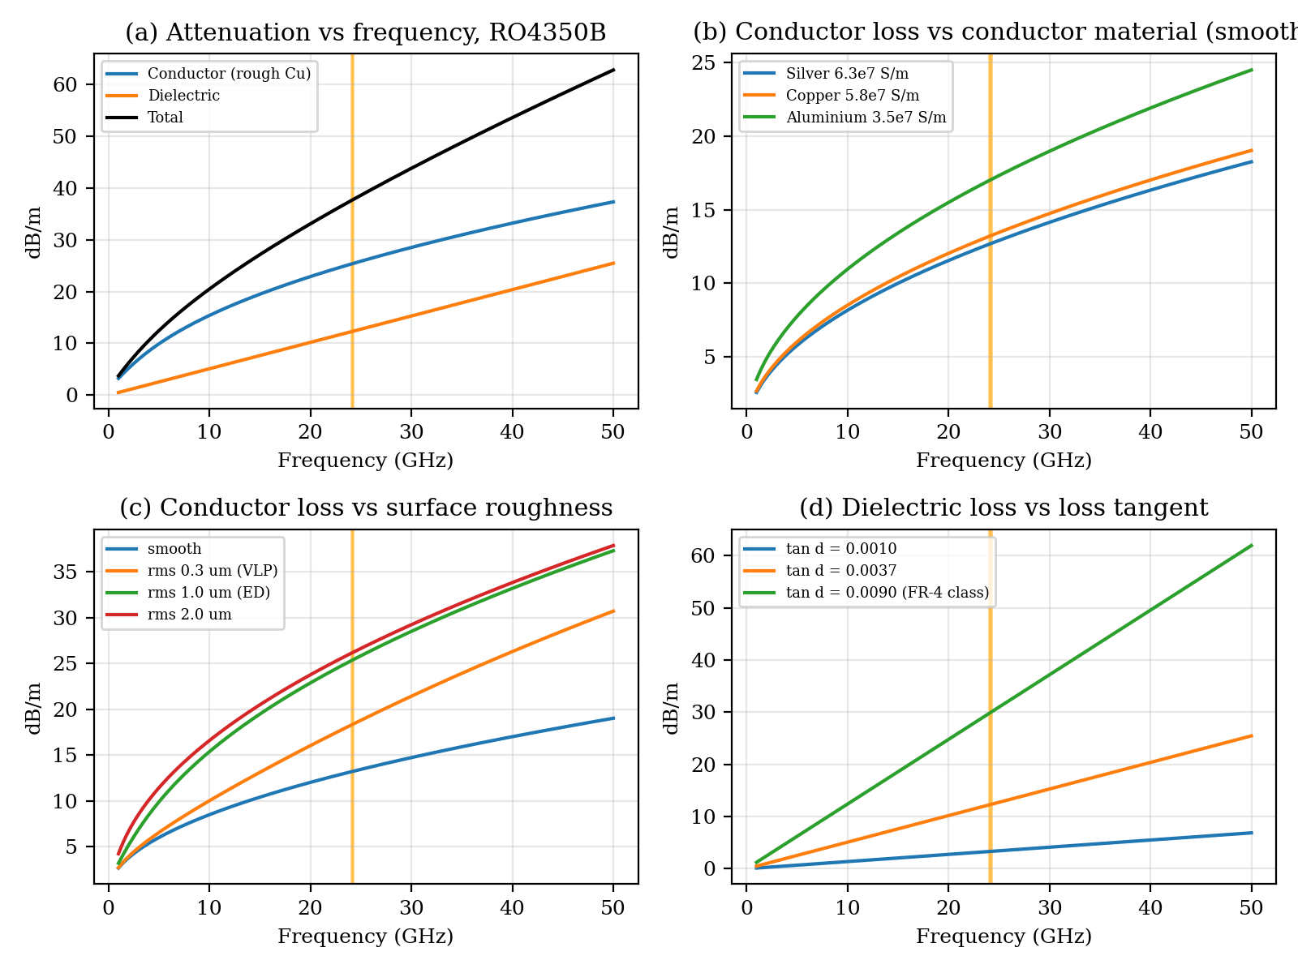
Figure 3 – Attenuation versus frequency (1–50 GHz) for the initial 50 Ω line: (a) components, (b) conductor material, (c) surface roughness, (d) loss tangent. The operating band is shaded.
- Frequency: conductor loss grows as √f (through Rs) and dielectric loss grows roughly linearly with f, so the dielectric share rises with frequency (40 % of distributed loss at 48 GHz against 26 % at 12 GHz).
- Conductor material: silver would reduce conductor loss by only about 4 % relative to copper and aluminium would raise it by about 29 %, so plating gives little gain compared with roughness.
- Surface roughness: once the RMS roughness exceeds the skin depth (0.43 µm), conductor loss approaches twice the smooth value; this is the single largest conductor-loss lever.
- Loss tangent: dielectric loss is directly proportional to tan δ; a FR-4 class laminate (tan δ ≈ 0.009) would give about 30 dB/m, which is unacceptable at 24 GHz.

Redesign and judgement
The adopted measures are: (1) RO3003 laminate (tan δ 0.0010, εr 3.00) in place of RO4350B; (2) low-profile copper (RMS 0.3 µm); (3) flip-chip MMIC attachment with an optimised launch and via fence; and (4) the quarter-wave transformer to remove the mismatch loss. The total falls from 1.86 dB to 0.71 dB, an improvement of 1.15 dB. The improved loss of 0.71 dB meets the 1.0 dB requirement with a margin of 0.29 dB. The trade-offs are a higher laminate and copper cost, a slightly wider line (0.615 mm), a lower εr (longer guided wavelength, so a slightly larger layout) and a narrowband transformer.
Design Decision 3: The dominant loss mechanism is conductor loss, contributing 40.9 % of the total in the initial design; the loss-reduction measure I adopt is RO3003 laminate with low-profile copper, flip-chip launch and a quarter-wave transformer, which reduces the attenuation from 1.86 to 0.71 dB over 30 mm.

STAGE 5 – CREATE AND EVALUATE THE NETWORK MODEL

Equivalent voltage and current
For a TEM or quasi-TEM line, V = −∫E·dl from the strip to the ground and I = ∮H·dl around the strip are unique and Z₀ = V/I. For a hollow waveguide the TE10 fields Ey = E₀ sin(πx/a) e^(−jβz) and Hx = −(E₀/ZTE) sin(πx/a) e^(−jβz) give no unique V or I: the voltage depends on the integration path and the current on which wall current is chosen. Equivalent modal quantities are defined by a normalisation. With V = E₀b and total power P = abE₀²/(4ZTE), the power–voltage definition gives Zeq = V²/(2P) = (2b/a)ZTE = (2 × 4.318/10.668) × 463.5 = 375.2 Ω, while the normalised choice Zeq = ZTE = 463.5 Ω is also common. This is why waveguide network results are quoted as S-parameters, which do not depend on the chosen normalisation.

Wave variables and ABCD formulation
a = (V + Z₀I)/(2√Z₀) b = (V − Z₀I)/(2√Z₀) Sij = bi/aj with other ports terminated in their reference impedance
A uniform section with characteristic impedance Zc, length l and γ = α + jβ has the ABCD matrix [A B; C D] = [cosh γl, Zc sinh γl; sinh γl/Zc, cosh γl]. For two cascaded sections Mtotal = M₁M₂. Here M₁ is the 50 Ω feed line of length 30 mm − λg,t/4 and M₂ is the 70.71 Ω transformer of length λg,t/4. For port reference impedances Z₀₁ (source side) and Z₀₂ (load side):
S11 = (A Z₀₂ + B − C Z₀₁Z₀₂ − D Z₀₁)/Δ S21 = 2√(Z₀₁Z₀₂)/Δ
S12 = 2√(Z₀₁Z₀₂)(AD − BC)/Δ S22 = (−A Z₀₂ + B − C Z₀₁Z₀₂ + D Z₀₁)/Δ
Δ = A Z₀₂ + B + C Z₀₁Z₀₂ + D Z₀₁
Port 1 is referenced to 50 Ω (MMIC) and port 2 to 100 Ω (patch element), so S11 is the reflection coefficient seen by the source and |S21|² is the power delivered to the 100 Ω load.

Load mismatch before matching
Without matching, the 100 Ω load is connected to the 50 Ω line. Lossless: Γ = (100 − 50)/(100 + 50) = 0.333; VSWR = (1 + |Γ|)/(1 − |Γ|) = 2.00; return loss = −20 log|Γ| = 9.54 dB; reflected power |Γ|² = 11.1 %. The 30 mm of lossy line lowers the reflection seen at the input to |S11| = 0.262 (RL = 11.63 dB, VSWR 1.71) because the reflected wave travels the line twice, but this is still below the 15 dB target, so the unmatched design fails the matching criterion. The reflection at the load itself is unchanged and wastes 0.51 dB.

Quarter-wave transformer
Zt = √(Z₀ZL) = √(50 × 100) = 70.71 Ω, with length l = λg,t/4 = 7.444/4 = 1.861 mm (90° at 24.15 GHz) and width Wt = 0.277 mm on RO4350B (0.331 mm and 2.018 mm on RO3003). Hand check: Zin = Zt²/ZL = 5000/100 = 50 Ω, so Γ = 0. In ABCD form the lossless QWT is [0 jZt; j/Zt 0], so Δ = jZt + j Z₀₁Z₀₂/Zt = j141.42 Ω, S11 = (B − CZ₀₁Z₀₂)/Δ = 0 and |S21| = 2√(Z₀₁Z₀₂)/|Δ| = 141.42/141.42 = 1.
For a single section with ZL/Z₀ = 2, the fractional bandwidth over which RL ≥ 15 dB (|Γm| = 0.1778) is Δf/f₀ = 2 − (4/π) arccos[(Γm/√(1 − Γm²)) · 2√(Z₀ZL)/|ZL − Z₀|] = 68.3 %, i.e. 16.5 GHz, far wider than the 0.83 % (0.2 GHz) operating band, so a single section is sufficient.

Network summary
Parameter (24.15 GHz) | Before matching (RO4350B) | After matching (RO3003 + QWT) | Target | Interpretation
Reference impedance Z₀ / load | 50 Ω to 100 Ω | 50 Ω → 70.71 Ω QWT → 100 Ω | 50 Ω system | Match by quarter-wave transformation
|Γ| = |S11| | 0.262 (lossless: 0.333) | 0.0058 | ≤ 0.178 | Lower is better
VSWR | 1.71 (lossless: 2.00) | 1.012 | ≤ 1.43 | Matched
Return loss (from S11) | 11.63 dB | 44.7 dB (band min 43.3 dB) | ≥ 15 dB | Before: fail. After: pass
Insertion loss (from S21) | 1.66 dB | 0.58 dB | ≤ 1.0 dB | With allowances 0.72 dB
Reciprocity S12 − S21 | 0.0000 | 0.0000 | 0 | Reciprocal
|S11|² + |S21|² (lossless / lossy) | 1.000 / 0.751 | 1.000 / 0.875 | 1 if lossless | Lossy: 12.5 % dissipated

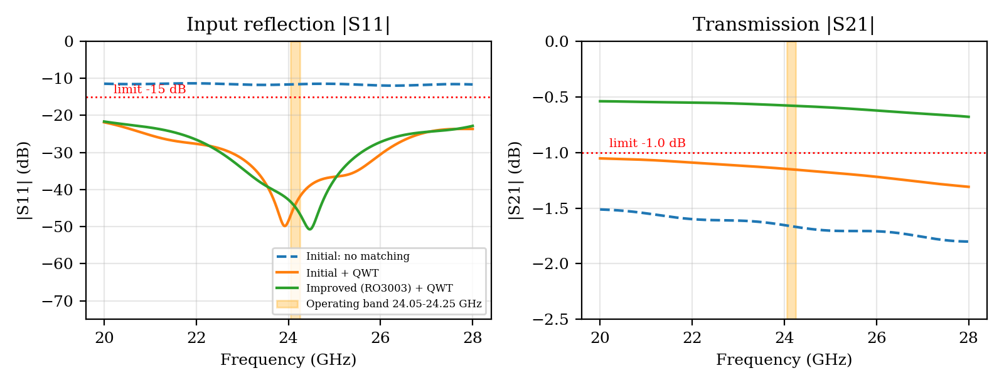
Figure 4 – Magnitude of S11 and S21 from 20 to 28 GHz for the unmatched, matched initial and improved designs (operating band shaded, limits dotted)
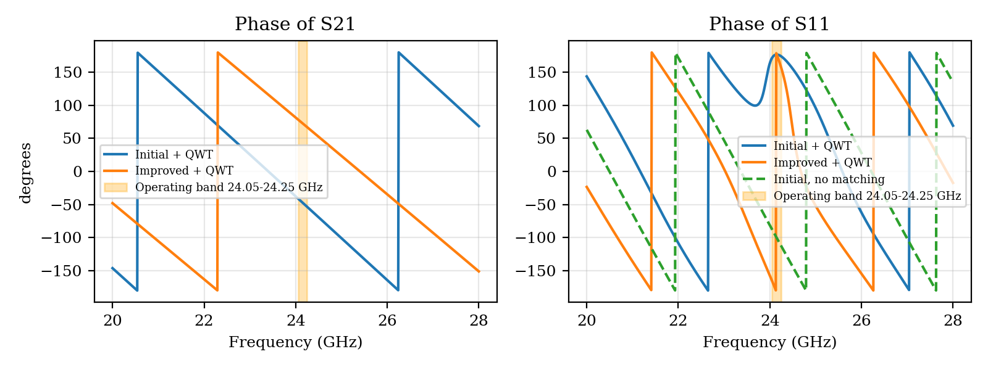
Figure 5 – Phase of S21 and S11 from 20 to 28 GHz
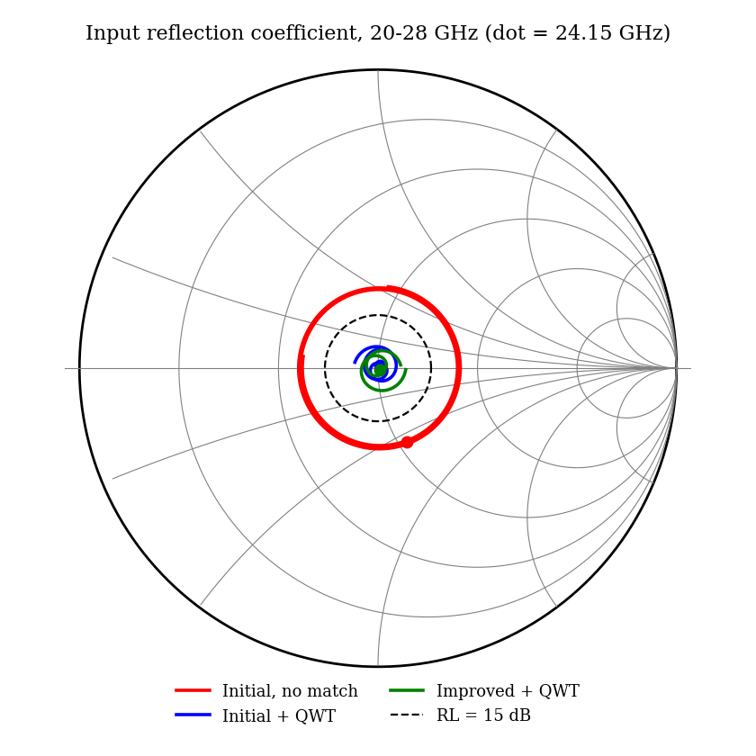
Figure 6 – Input reflection coefficient on the Smith chart (scikit-rf model, 100 Ω load); the dashed circle is the 15 dB return-loss limit

S-parameter properties
Reciprocity: S12 equals S21 to numerical precision (0.9354 against 0.9354) because the line and transformer are passive, isotropic and contain no non-reciprocal material (AD − BC = 1). Symmetry: S11 ≠ S22 (0.262 against 0.340 before matching) because the network is not geometrically symmetric and the ports have different references, so only reciprocity holds. Losslessness: with loss set to zero, |S11|² + |S21|² = 1.0000; with real loss it is 0.875, so the S-matrix is not unitary, which is the expected result for a lossy line. Matching: |S11| is small and |S21| is close to 0.94 after matching. Return loss = −20 log|S11| and insertion loss = −20 log|S21|.
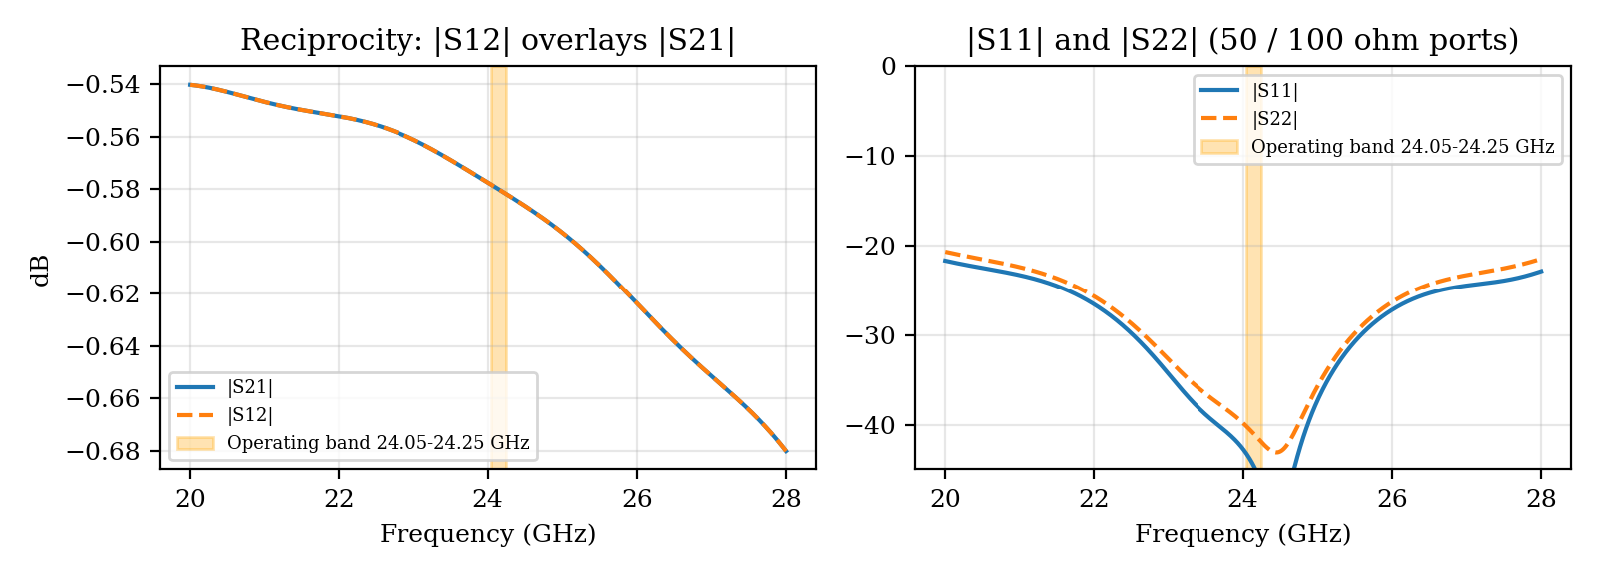
Figure 7 – Reciprocity (|S12| overlays |S21|) and S11/S22 of the improved matched design

Independent verification
The ABCD/S-parameter model was cross-checked against the scikit-rf MLine microstrip model (Hammerstad–Jensen statics, Kirschning–Jansen dispersion, built-in conductor and dielectric loss), cascading the same line and transformer and terminating in 100 Ω. The two models differ in their loss formulas, so a difference is expected.
Quantity at 24.15 GHz | Hand / ABCD model | scikit-rf model | Difference | Comment
Z₀ of 50 Ω line (initial) | 49.38 Ω | 50.44 Ω | 1.07 Ω | Within 1.2 %
εeff of 50 Ω line (initial) | 2.931 | 2.874 | -0.057 | Dispersion model differs
Attenuation, initial (dB/m) | 37.7 | 31.1 | -17 % | Hand model is conservative
Attenuation, improved (dB/m) | 18.9 | 14.8 | -22 % | Hand model is conservative
RL, initial unmatched (dB) | 11.63 | 11.49 | -0.14 dB | Agrees
IL, initial unmatched (dB) | 1.66 | 1.44 | -0.22 dB | Loss model difference
RL, improved + QWT (dB) | 44.7 | 40.3 | -4.4 dB | Both ≫ 15 dB
IL, improved + QWT (dB) | 0.580 | 0.451 | -0.129 dB | Both < 1.0 dB

The independent model gives return-loss agreement for the unmatched case and about 17–28 % lower attenuation than the hand model, so the design values above are on the conservative side. Neither is a substitute for a full-wave solver or VNA measurement; no plot in this report is output from a field solver. Code is given in Appendix B.
Network decision: the unmatched 100 Ω load fails the 15 dB return-loss target (11.6 dB). The 70.71 Ω quarter-wave transformer brings the return loss to 44.7 dB at f₀ and at least 43.3 dB across the band in the model; real compliance depends on the launch and manufacturing tolerance (Stage 6).

STAGE 6 – VALIDATE, CRITIQUE AND TOLERANCE ANALYSIS

Specification verification
Requirement | Specified | Initial design | Final design (worst case) | Satisfied?
Operating frequency / single-mode range | 24.05–24.25 GHz | Quasi-TEM, single-mode to ≈ 78 GHz | Single-mode to ≈ 78 GHz; launch to be verified | Yes (model); full-wave pending
Dominant mode and cutoff | Quasi-TEM, no cutoff | Quasi-TEM | Quasi-TEM; first limits 78 and 121 GHz | Yes
Insertion loss / attenuation | ≤ 1.0 dB / 30 mm | 1.86 dB | 0.76 dB (S21 worst 0.61 + allowances 0.14) | Initial: No. Final: Yes
Impedance / VSWR | 50 Ω / ≤ 1.43 | VSWR 1.71 | Z₀ 46.5–53.7 Ω over ±5 % W, ±5 % h, ±2 % εr | Initial: No. Final: Yes
Return loss (S11) | ≥ 15 dB | 11.6 dB | 25.3 dB worst corner | Initial: No. Final: Yes
EMI shielding / isolation | ≥ 30 dB | Not measured | Via fence at λg/10 pitch, solid ground plane | Pending EMC test
Power handling / size | +10 dBm / ≤ 30 mm | 30 mm line | 30 mm line; 10 mW is far below any thermal limit of the line | Yes (thermal and connector ratings to be checked)

Tolerance analysis
The improved design was analysed over all corners of ±5 % strip width (the transformer width varied together), ±5 % substrate thickness and ±2 % εr, and over 24.05–24.25 GHz. The line impedance varies between 46.5 Ω and 53.7 Ω, the worst-case return loss is 25.3 dB and the worst-case S21 loss is 0.61 dB. Adding the transition and radiation allowances (0.14 dB) gives 0.76 dB, still below 1.0 dB. Single-parameter results are:
Variation (improved design) | Z₀ of 50 Ω line (Ω) | Worst RL in band (dB) | Worst S21 loss in band (dB)
W -5 % | 51.60 | 34.9 | 0.593
W +5 % | 48.50 | 30.7 | 0.576
h -5 % | 48.38 | 30.2 | 0.602
h +5 % | 51.57 | 35.3 | 0.568
er -2 % | 50.44 | 43.4 | 0.576
er +2 % | 49.57 | 38.5 | 0.588

A ±3 % change in εeff changes vp = c/√εeff by about ∓1.5 % and the guided wavelength by the same amount, so the quarter-wave length of the transformer is in error by ±1.5 % (±1.35° of electrical length). For an ideal lossless transformer this gives a return loss of 41.6 dB, which is still far better than 15 dB, because the load ratio is only 2:1 and the section is wideband. The real sensitivity is therefore in the Z₀ error of the 50 Ω feed (up to 3.5 % reflection per interface), which is why the design remains robust but not immune to etch error.

Assumptions and their impact
- Ideal conductor / uniform copper: the model includes skin effect and roughness (Hammerstad correction), but the true roughness profile is not known and could change conductor loss by tens of percent, as the scikit-rf comparison shows.
- Constant εr and tan δ: datasheet values are measured near 10 GHz; εr and tan δ drift with frequency, temperature and lot, which moves Z₀ and loss.
- Quasi-static statics with Getsinger dispersion: accurate to a few percent for h/λd = 0.04; connectors, bends, launches and surface-wave coupling are not captured.
- Resistive 100 Ω load: a real patch element is complex and varies with frequency; a single quarter-wave section matches only the real part.
- Allowances: radiation and transition losses are assumed, not calculated; they total 0.14 dB (improved) and could be higher.

EMC, safety and experimental test plan
- Inspect ground continuity, via-fence spacing, solder quality and board cleanliness before powering the circuit.
- Calibrate a VNA (24 GHz capable cables, TRL or SOLT standards) at the board reference plane; measure S11 and S21 from 20 to 28 GHz and compare with the limits in this report; use time-domain gating to separate the launch.
- Measure coupling (S31) between adjacent lines to verify the 30 dB isolation target and use near-field probes and a spectrum analyser to locate leakage.
- Check radiated emissions and exposure for the complete system (antenna gain, duty cycle, distance) against the applicable standards; do not infer exposure compliance from conducted power.
- Repeat on at least three boards from more than one panel; record calibration method, laminate lot and temperature, and measure over the automotive temperature range.

Proposed further improvement
If the measured loss or return loss fails, first re-optimise the launch and transformer width with a full-wave solver. If the loss is still above 1.0 dB, use a thinner or smoother conductor stack, a lower-loss laminate or a substrate-integrated waveguide section. If a wider band is later needed (for example a swept bandwidth above 16 GHz), use a two-section or tapered transformer; the improved design should be re-simulated, fabricated and measured before release.

FINAL ENGINEERING DECISION
Should this structure and mode be adopted for the application?
(i) Initial design (RO4350B, wire-bond launch, 100 Ω load connected directly): NO. The return loss is 11.6 dB (VSWR 1.71) against ≥ 15 dB (VSWR ≤ 1.43), and the total loss is 1.86 dB against ≤ 1.0 dB. Conductor loss is dominant at 40.9 % of the total and mismatch adds 27.5 %. Even with a transformer fitted, the RO4350B line still loses 1.35 dB.
(ii) Final design (50 Ω microstrip on RO3003 with low-profile copper, flip-chip launch and a 70.71 Ω quarter-wave transformer): CONDITIONAL YES. The quasi-TEM mode is well clear of higher-order modes (78 GHz and 121 GHz against 24.25 GHz); the estimated loss is 0.71 dB (worst case 0.76 dB) against 1.0 dB; the return loss is 45 dB at f₀ and 25.3 dB in the worst tolerance corner against 15 dB; and the design stays within specification for ±5 % width and thickness and ±2 % εr. The EMC behaviour depends on the via fence and ground layout and the isolation target of 30 dB is not yet measured.
The design should therefore be adopted for prototype development, not released for production, until full-wave simulation of the launch, the VNA measurements of S11, S21 and isolation, and the exposure assessment have shown compliance across 24.05–24.25 GHz. It would be technically incorrect to claim these tests have been passed now.
Remaining non-compliance and further change. The remaining open items are the unverified launch loss and radiation allowance (assumed 0.14 dB) and the unmeasured isolation. If measurement shows more than about 0.25 dB of additional loss, the next change would be a lower-roughness conductor or a substrate-integrated waveguide section for the longest runs. This would lower conductor loss further and keep the mode single, at the cost of a larger layout and a more complex transition.

REFERENCES
1. D. M. Pozar, Microwave Engineering, 4th ed., Wiley, 2012.
2. R. E. Collin, Foundations for Microwave Engineering, 2nd ed., IEEE Press/Wiley, 2001.
3. E. Hammerstad and O. Jensen, “Accurate models for microstrip computer-aided design,” IEEE MTT-S Int. Microwave Symp. Dig., 1980, pp. 407–409.
4. W. J. Getsinger, “Microstrip dispersion model,” IEEE Trans. Microw. Theory Techn., vol. 21, no. 1, 1973, pp. 34–39.
5. M. Kirschning and R. H. Jansen, “Accurate model for effective dielectric constant of microstrip with validity up to millimetre-wave frequencies,” Electron. Lett., vol. 18, 1982, pp. 272–273.
6. C. A. Balanis, Advanced Engineering Electromagnetics, 2nd ed., Wiley, 2012.
7. Rogers Corporation, RO4350B and RO3003 laminate datasheets (use the revision supplied with the board).
8. scikit-rf documentation, skrf.media.MLine, https://scikit-rf.org.
9. ITU-R Recommendation P.838, Specific attenuation model for rain for use in prediction methods.
10. ICNIRP, “Guidelines for limiting exposure to electromagnetic fields (100 kHz to 300 GHz),” Health Physics, vol. 118, no. 5, 2020.

APPENDIX A – FORMULA SUMMARY
Quantity | Formula
Free-space wavelength | λ₀ = c/f
Propagation constant | γ = √[(R + jωL)(G + jωC)] = α + jβ
Low-loss attenuation | α ≈ R/(2Z₀) + GZ₀/2; β ≈ ω√(LC)
Microstrip εeff, Z₀ (static) | Hammerstad–Jensen; Z₀ = Z₀₁/√εeff₀
Dispersion | εeff(f) = εr − (εr − εeff₀)/(1 + G(f/fp)²); fp = Z₀/(2μ₀h); G = 0.6 + 0.009Z₀
Skin depth / surface resistance | δ = √(2/ωμσ); Rs = √(πfμ/σ)
Roughness factor | K = 1 + (2/π) arctan[1.4(Δ/δ)²]
Conductor attenuation (microstrip) | αc ≈ Rs K/(Z₀W) Np/m
Dielectric attenuation (microstrip) | αd = k₀εr(εeff − 1)tan δ / [2√εeff(εr − 1)] Np/m
Np/m to dB/m | α(dB/m) = 8.686 α(Np/m)
Reflection coefficient, VSWR, RL | Γ = (ZL − Z₀)/(ZL + Z₀); VSWR = (1 + |Γ|)/(1 − |Γ|); RL = −20 log|Γ|
Quarter-wave transformer | Zt = √(Z₀ZL); l = λg/4
Waveguide (TE10) | fc = c/2a; λg = λ₀/√(1 − (fc/f)²); vp = c/√(1 − (fc/f)²); vg = c√(1 − (fc/f)²); ZTE = η/√(1 − (fc/f)²)
Group delay | τg = −d∠S21/dω ≈ l/vg

APPENDIX B – CODE LISTING (EXTRACT)
Python/NumPy functions used for the ABCD cascade and S-parameters (the same model generated all tables and figures; the scikit-rf check used skrf.media.MLine with the same geometry).
def line_abcd(f, Zc, L, alpha_np, er_eff):
beta = 2*np.pi*f*np.sqrt(er_eff)/c
g = alpha_np + 1j*beta
ch, sh = np.cosh(g*L), np.sinh(g*L)
return np.array([[ch, Zc*sh], [sh/Zc, ch]])

def abcd2s(M, z1, z2):
A, B, C, D = M[0,0], M[0,1], M[1,0], M[1,1]
den = A*z2 + B + C*z1*z2 + D*z1
S11 = (A*z2 + B - C*z1*z2 - D*z1)/den
S21 = 2*np.sqrt(z1*z2)/den
S12 = 2*np.sqrt(z1*z2)*(A*D - B*C)/den
S22 = (-A*z2 + B - C*z1*z2 + D*z1)/den
return S11, S21, S12, S22

# feed line (50 ohm) followed by quarter-wave section (70.71 ohm); ports 50 / 100 ohm
M = line_abcd(f, 50.0, L_feed, a_feed, eeff50) @ line_abcd(f, 70.71, L_qwt, a_qwt, eeffT)
S11, S21, S12, S22 = abcd2s(M, 50.0, 100.0)
RL = -20*np.log10(abs(S11)); IL = -20*np.log10(abs(S21))
Submission note: replace the assumed values (patch resistance, transition and radiation allowances, laminate datasheet values) with instructor-approved or supplier values, and attach full-wave or VNA plots if required.

